**APPLICATION OF FOURIER SERIES**

**LAB # 09**



**CSE301L Signals & Systems Lab**

Submitted by: **Shah Raza**

Registration No: **18PWCSE1658**

Class Section: **B**

“On my honor, as a student of University of Engineering and Technology, I have neither given nor received unauthorized assistance on this academic work.”

Student Signature: ______________

Submitted to: **Engr. Durr-e-Nayab**

Friday, July 31st, 2020

**Department of Computer Systems Engineering**

**University of Engineering and Technology, Peshawar**

**Lab Objectives:**

Objectives of this lab are as follows:

* Power of Continuous & Discrete time Signals
* Application of Fourier Series
* Synthesis of Square Wave
* Synthesis of Triangular Wave

**Task # 1:**

Calculate the power of discrete‐time cosine signal with period 20, defined over interval 0:19 using the following formula:



**Problem Analysis:**

Choose a cosine signal and put the values in the above formula to find the power of the signal and plot the signal.

**Code:**

n = 0:0.15:19; % time duration of given signal;

x = cos(2*pi*n/2);

stem(n, x,'filled'); % plot signal

xlabel('Index Value, n');

ylabel('Amplitude, A');

title('Discrete Time Cosine');

abs_x_2 = abs(x).^2; % Absolute square of signal

N = 20; % length of interval

delta_n = 0.25; % interval duration

px = sum(abs_x_2)*delta_n/N

**Result:**

Power of the signal, px = 0.4775

**Output:**

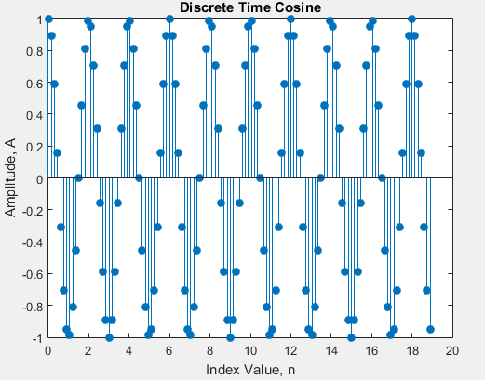

**Task # 2:**

Analyze the effect of Adding 1st to 17th harmonics and the effect of Adding 1st to 27th harmonics in above example.

**Code:**

**1st to 17th Harmonic:**

clc

clear all

close all

ff=0.5;

fs=1000;

t=0:1/fs:8;

A=4/pi;

har1=A*sin(2*pi*ff*t);

for k=3:2:34

A=4/(pi*k);

har2=A*sin(2*pi*ff*t*k);

har1=har1+har2;

end

plot(t,har1,'linewidth',1.5);

title('A square wave with harmonic 1 to 17');

xlabel('Time');

ylabel('Amplitude');

**1st to 27th Harmonic:**

clc

clear all

close all

ff=0.5;

fs=1000;

t=0:1/fs:8;

A=4/pi;

har1=A*sin(2*pi*ff*t);

for k=3:2:55

A=4/(pi*k);

har2=A*sin(2*pi*ff*t*k);

har1=har1+har2;

end

plot(t,har1,'linewidth',1.5);

title('A square wave with harmonic 1 to 27');

xlabel('Time');

ylabel('Amplitude');

**Output:**

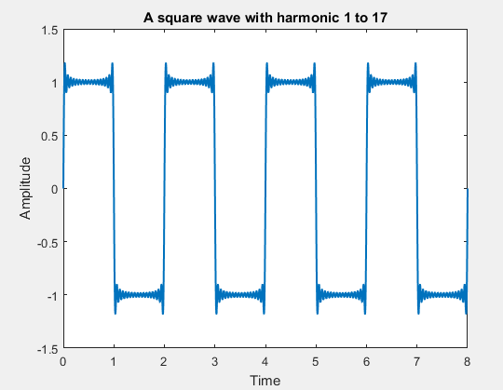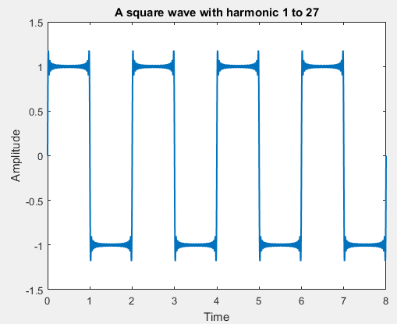

**Task # 3:**

Write a program that plots the signal s(t).

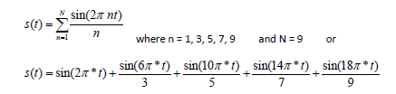

**Problem Analysis:**

Take the sum of the given sine signal for different values of n and plot the resultant signal.

**Code:**

t=0:0.0001:10;

N=9;

y = sin(2*pi*t);

for n = 1:2:9 %Odd numbers from 1 to 9

x = sin(2*pi*n*t)/n;

y=y+x; %Summation of Signals

end

plot(t,y,'linewidth',1.5); %Plot signal

title('A wave with harmonics 1st to 9th');

xlabel('Time');

ylabel('Amplitude');

**Output:**

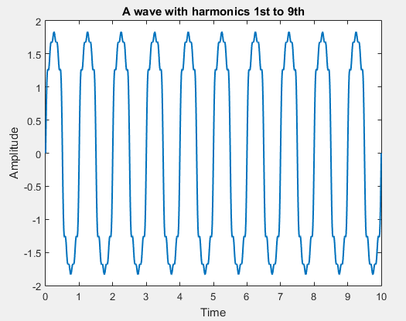

**Task # 4:**

Generate a triangular wave with N=11.

**Code:**

clc

clear all

close all

t=0:0.01:0.25;

ff=25;

x1=(-8/(pi^2))*exp(i*(2*pi*ff*t));

for k=3:2:21

fh=ff*k;

x=(-8/(pi^2*k^2))*exp(i*(2*pi*fh*t));

y=x1+x;

end

plot(t,real(y),'linewidth',3);

title('Triangular Wave with N=11');

ylabel('Amplitude');

xlabel('Time');

grid;

**Output:**

